**Template Method pattern**

The template method pattern defines the general algorithm steps, postponing the implementation of some steps to the subclasses that extend it. It’s best used when we can generalize two subclasses to a new superclasses.

**Code Snippet**

**Code location**

SidePaneComponent class (Abstract)

*Src/main/java/org/jabref/gui/sidepane/SidePaneComponent*



Abstract method in the SidePaneComponent class getType()

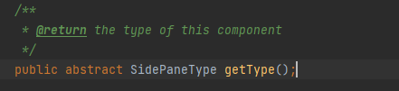

WebSearchPane class in method getType()

*Src/main/java/org/jabref/gui/importer/fetcher/WebSearchPane*

GroupSidePane class in method getType()

*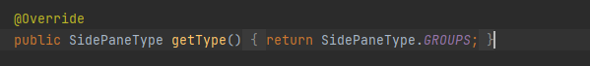Src/main/java/org/jabref/gui/groups/GroupSidePane*

**Justification**

In this case the method pattern is being instanciated beacause the WebSearchPane and the GroupSidePane clases extend the same abstract method, getType() of the class SidePaneComponent, also abstract.